10 Days

10 Days Requirement

- Tracking api
- Customer service (admin - seller) & (admin - end customer)
- Products Adding in Dashboard Management (Dynamic)
- Create listing flow change

Create listing flow change

None Variant

- Is this an own branded product ?
Yes/No
If Yes then blank box shud show with dropdown of their brands then they can choose category
If No then no blank box of brands then they can choose category
This question should be only asked to sellers who tick for unbranded products while onboarding
- Then ask this (as in the screenshot)
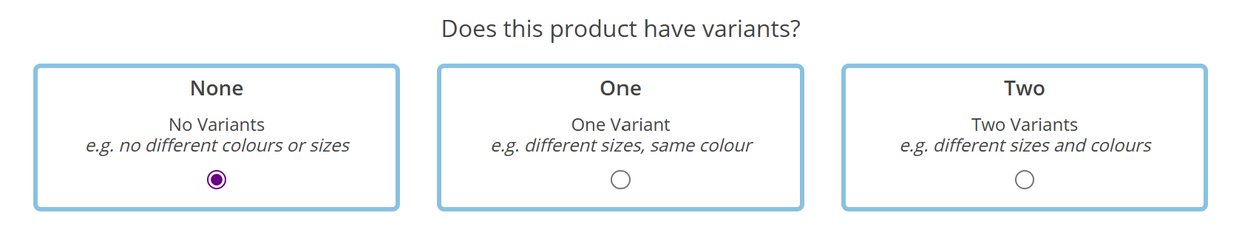
- Ask sku, sku should be auto generated in the box or without generating sku they shouldn't be able to jump to the next stage
- Then product title (50 - 65 character limit)
- Then ask this (as in the screenshot)
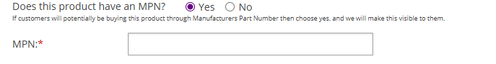
If clicked on Yes, then show blank box
If clicked on No, then nothing
Show info for MPN - An official product number assigned by the manufacturer. It helps identify the exact model or version of an item (often found on the packaging, label, or manual).
- Then ask this
Only ask What is the EAN, UPC of the product (show them they can skip this question if they don't have this code)
- No need of active product on/off on the first page
- 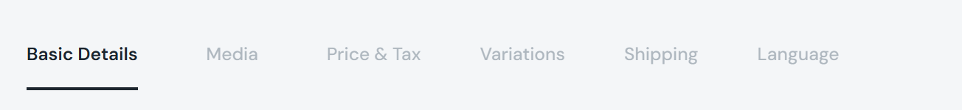
The above screenshot is our current listing flow. Should be changed to
Basic Details, Variations, Media, Detailed Product Info, Price & Tax, Shipping, Language
Hide language section for time being instead Review section
- If the seller has selected no variants for the product, then they should land in Media by skipping Variations
- Then in Detailed Product Info,
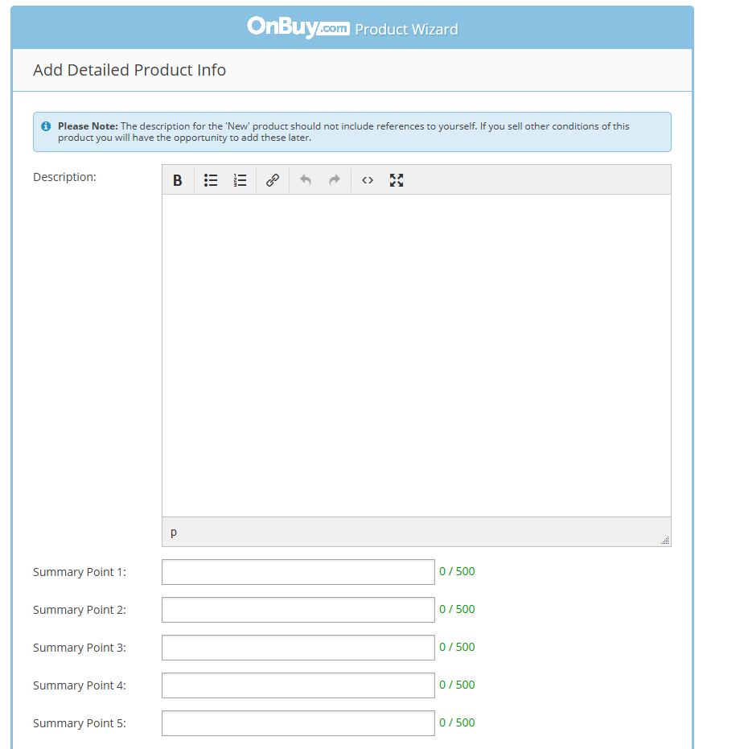
We can ask for highlights here, we'll make it so they can add upto 5 points with 0-500 character limit
- Then in Price and tax,
- Hide minimum quantity

- Move the discount box to the left and then ask for discount percentage
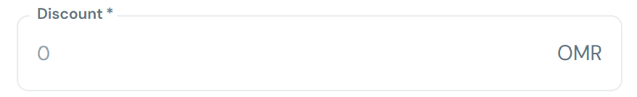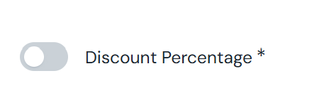
- Place the include tax toggle below to price box
- Then in price and tax, ask for discount start date and end date (Refer video) https://drive.google.com/file/d/1qA7MuxmHbQ5937WDpUY5VF1Zyn72YtmR/view?usp=drive_link
- Length Width Height Weight should be hidden in Shipping details
Reason: These are not required at listing stage because shipping charges will be calculated based on actual courier scans (Asyad). Collecting them from sellers is inaccurate, redundant, and adds friction to the listing flow
- Shipping charge should be shown 2omr, the box should be unclickable
- Shipping Days should also be unclickable showing 5-7 days.
- In return time show them the standard return time for Kaartx is 7 days, sellers can set their own return time as its not harming us in anyways. NOTE: They should not be able to set a time period below 7 days
If the item is returnable or refundable, it should be displayed in the product page
(will update in figma)
- After ask whether the item is returnable or not with a toggle
- If the Returnable toggle is on, then only ask for refundable toggle (needed)
- Also for Cancellation time, sellers can choose their own cancellation time
Standard cancellation time:5 hours, should not be below this time
- Hide warranty toggle, warranty duration & warranty description for now
- Then the final stage should be the Review section as per our listing flow as in the screenshot (Refer video for indepth knowledge)
https://drive.google.com/file/d/1uEgmoDjCrCcfg6ZA8gHihThquhCwLPvW/view?usp=drive_link
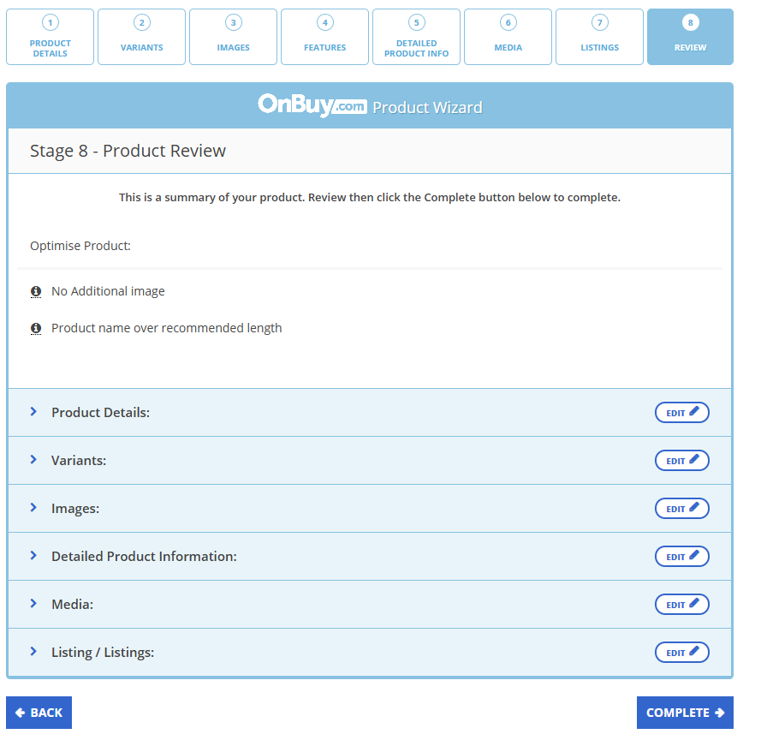

One Variant
- Is this an own-branded product ?
Yes/No
If Yes then blank box shud show with dropdown of their brands then they can choose category
If No then no blank box of brands then they can choose category
This question should be only asked to sellers who tick for unbranded products while onboarding
- Then ask this (as in the screenshot)
If clicked on one variant
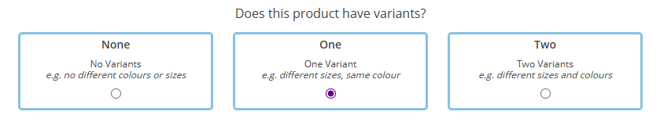
Also add eg: different colours, same size in one variant box
- Then product title (50 - 65 character limit)
- No need of active product on/off on the first page
- Basic Details, Variations, Media, Detailed Product Info, Price & Tax, Shipping, Language
Hide language section for time being instead Review section
- Then go to Variations and ask as in the screenshot
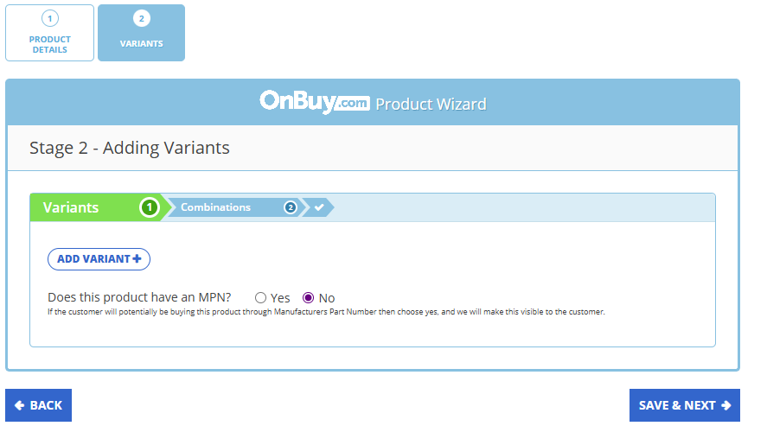
Does this product have an MPN ?
Yes/No
Show info for MPN - An official product number assigned by the manufacturer. It helps identify the exact model or version of an item (often found on the packaging, label, or manual).
- If clicked No dont ask anything here
- If clicked Yes, then only ask for the next question in the screenshot
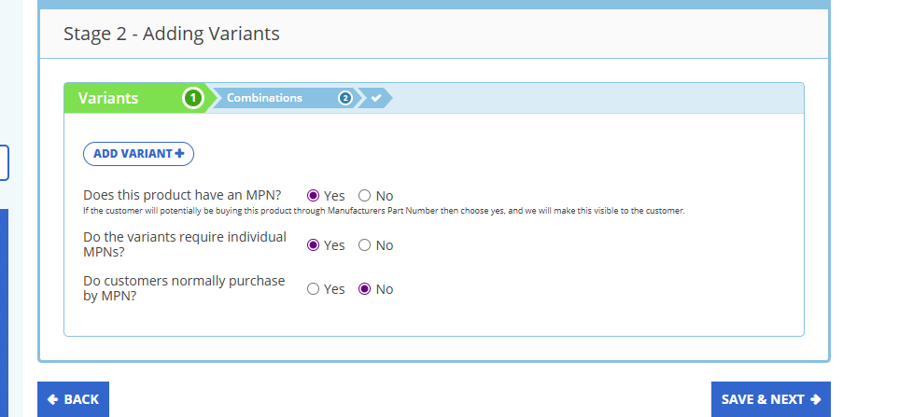
Do the variants require individual MPNs?
Yes/No
If clicked on No, then ask the MPN directly as in the below screenshot
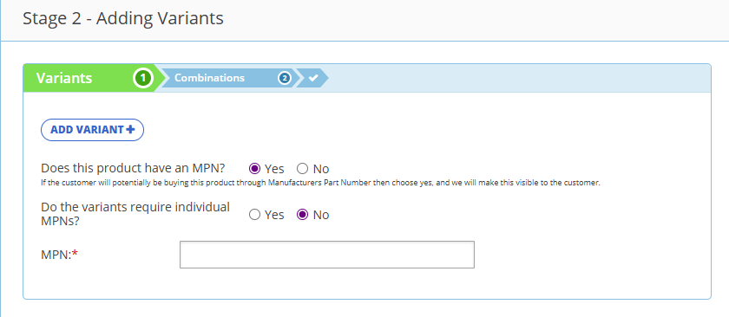
If clicked Yes, MPN shud be asked from the option details (as we discussed today 19th sept. in meet)
- When clicked on add variant ask for variant name
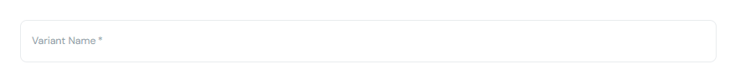Above provided is Kaartx dash screenshot
Somewhere provide a tooltip saying eg: colour or size
- Below provided is kaartx dash screenshot, instead of simply asking for options type,
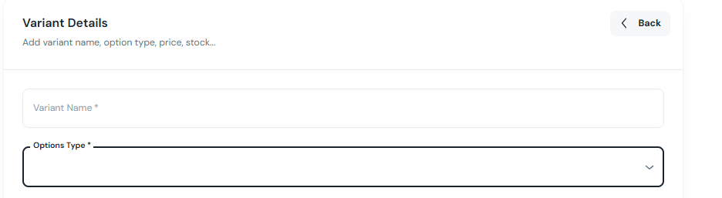
If Colour is entered then ask Colour options instead of options type and allow sellers to add up
If Size is entered then ask Size options instead of options type and allow sellers to add up
Change the box with dropdown and place something like sellers can add up,find the example below:
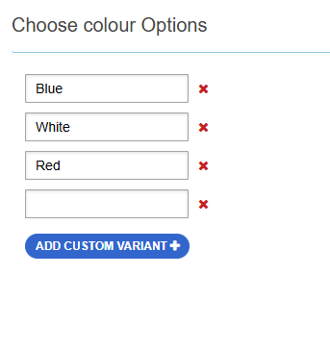
- Variants section should be having two parts. After adding options then comes the next part of the variant section (as in the screenshot below)
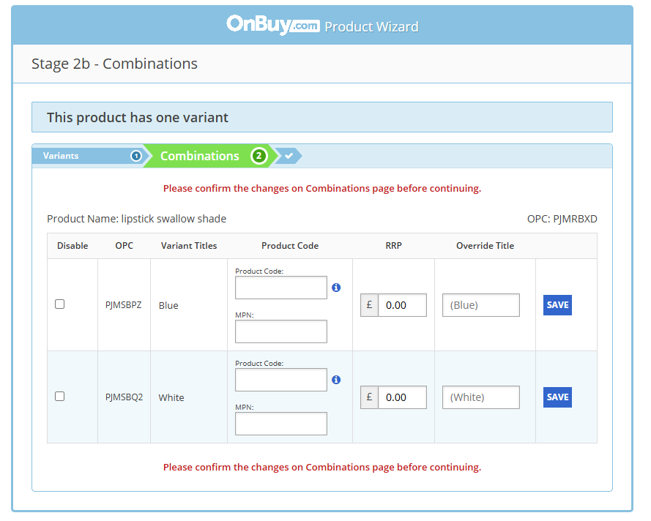
- Instead of opc write Sku
Auto generated skus in the rows or a small box inside the row to generate sku
- Third row Is needed
- Inside the first box in fourth row, first box writing should be EAN, UPC & second box as it is in the screenshot (MPN)
- RRP row not needed
- Override title needed without save and it shud be unclickable for sellers
- Without entering EAN & UPC, sellers can go to next step but if they had clicked yes for the question ‘Do the variants require individual MPNs’ then they cant jump to next stage without entering MPN
- Then Media section
Ask Do variants have different images? Yes/No
If clicked No then
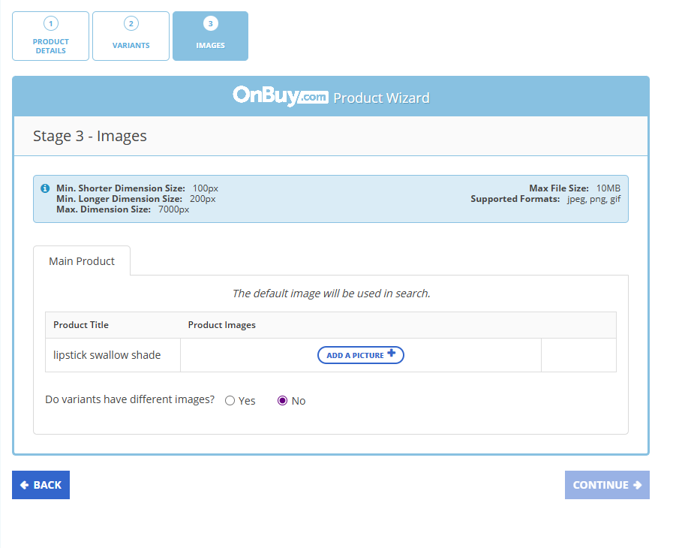
(Add standards for images)
If clicked Yes then
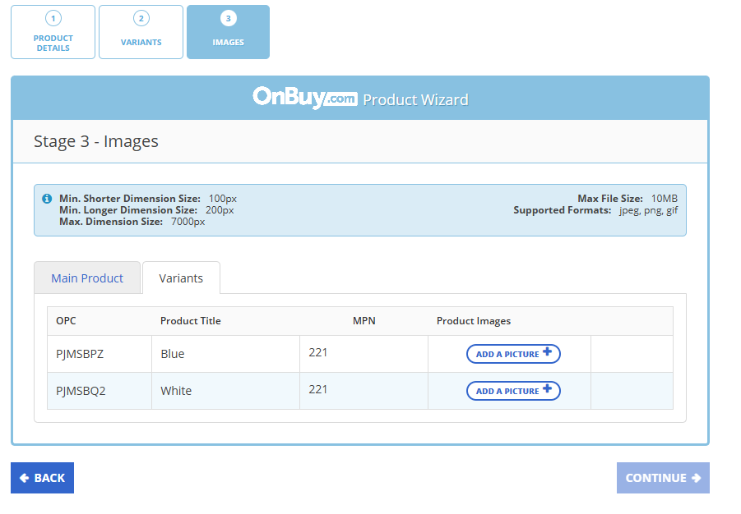
- Then in Detailed Product Info,
Ask ‘Do variants have different descriptions?’
If clicked No,then common description box & highlights adding box (refer screenshot below)
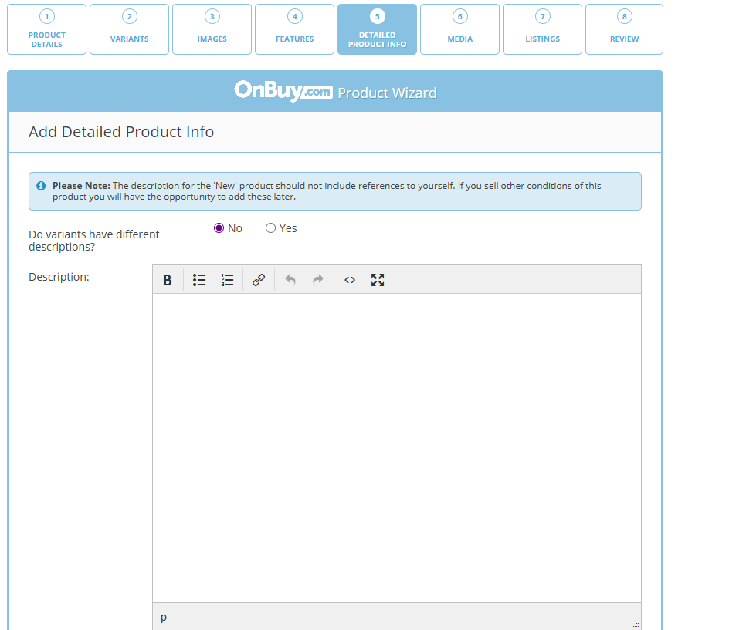
If clicked Yes, then description box & highlights adding box specifically for each variant (refer the video below in the link)
Description.mp4
- Then in Price & Tax,
- Hide minimum quantity
- Discount should be specifically asked for each variants
- Then ask discount start date & end date for each variants
https://drive.google.com/file/d/1qA7MuxmHbQ5937WDpUY5VF1Zyn72YtmR/vie
w?usp=drive_link
- Include tax toggle should be placed accordingly for all variants
- Ask price in this way for particular variants
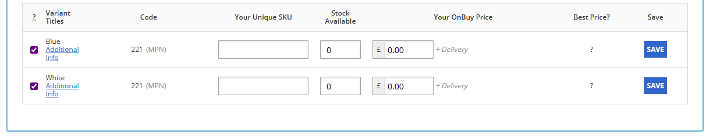
- Auto generated sku shud show in the third row
- Previously entered stock should show there
- Then box to enter price
- When clicked on additional info, Onbuy gives option to add sale price and all
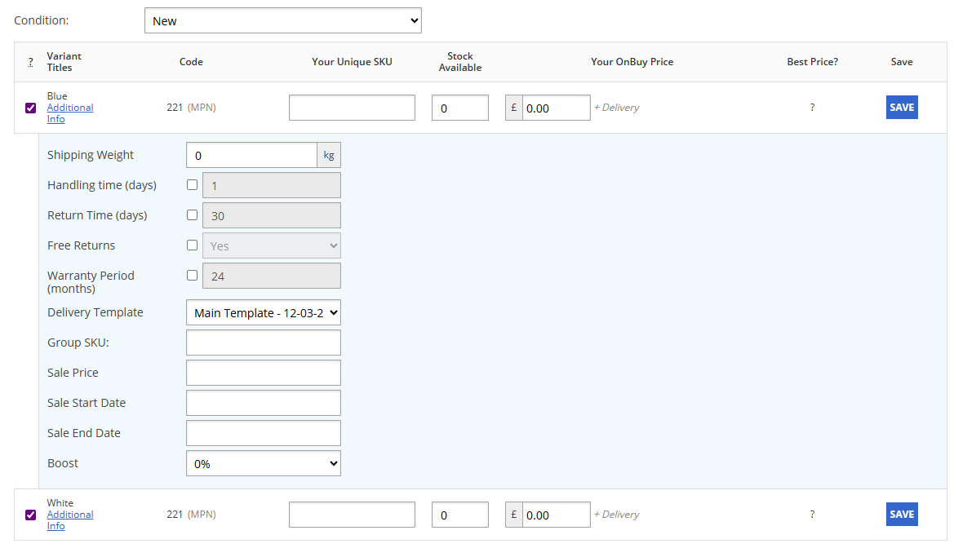
- Then Shipping
- Below questions should be asked for each variants
- Length Width Height Weight should be hidden in Shipping details
Reason: These are not required at listing stage because shipping charges will be calculated based on actual courier scans (Asyad). Collecting them from sellers is inaccurate, redundant, and adds friction to the listing flow
- Shipping charge should be shown 2omr, the box should be unclickable
- Shipping Days should also be unclickable showing 5-7 days.
- In return time show them the standard return time for Kaartx is 7 days, sellers can set their own return time as its not harming us in anyways. NOTE: They should not be able to set a time period below 7 days
If the item is returnable or refundable, it should be displayed in the product page
(will update in figma)
- After ask whether the item is returnable or not, with a toggle
- If the Returnable toggle is on, then only ask for refundable toggle (needed)
- Also for Cancellation time, sellers can choose their own cancellation time
Standard cancellation time:5 hours, should not be below this time
- Hide warranty toggle, warranty duration & warranty description for now
- Then Review

Two Variant
- Is this an own branded product ?
Yes/No
If Yes then blank box shud show with dropdown of their brands then they can choose category
If No then no blank box of brands then they can choose category
This question should be only asked to sellers who tick for unbranded products while onboarding
- Then ask this (as in the screenshot)
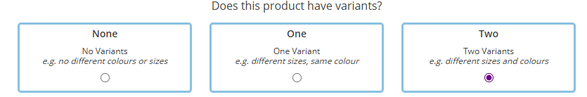
- Then product title (50 - 65 character limit)
- No need of active product on/off on the first page
- Basic Details, Variations, Media, Detailed Product Info, Price & Tax, Shipping, Language
Hide language section for time being instead Review section
- Then go to Variations and ask as in the screenshot
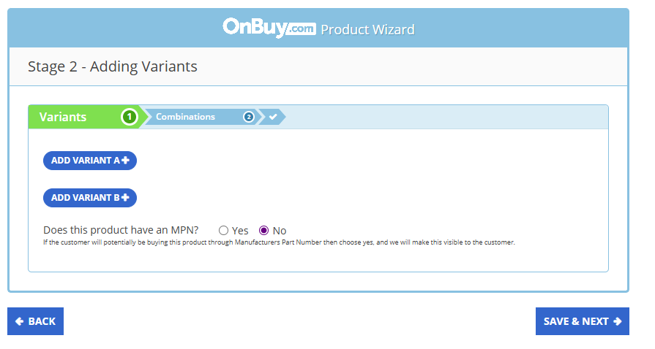
Does this product have an MPN ?
Yes/No
Show info for MPN - An official product number assigned by the manufacturer. It helps identify the exact model or version of an item (often found on the packaging, label, or manual).
- If clicked No dont ask anything here
- If clicked Yes, then only ask for the next question in the screenshot
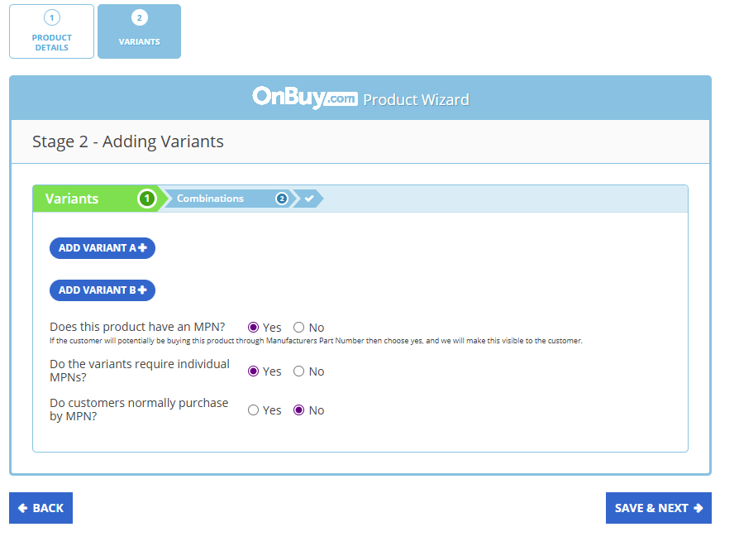
Do the variants require individual MPNs?
Yes/No
If clicked on No, then ask the MPN directly as in the below screenshot
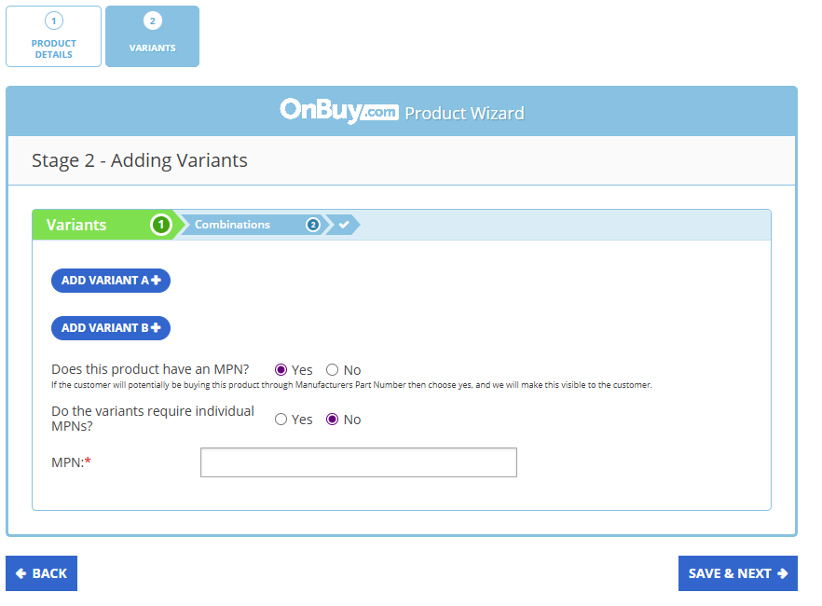
If clicked Yes, MPN shud be asked from the option details (as we discussed today(19th sept.) in meet)
- After adding two variants, OnBuy is showing like this as in the below screenshot
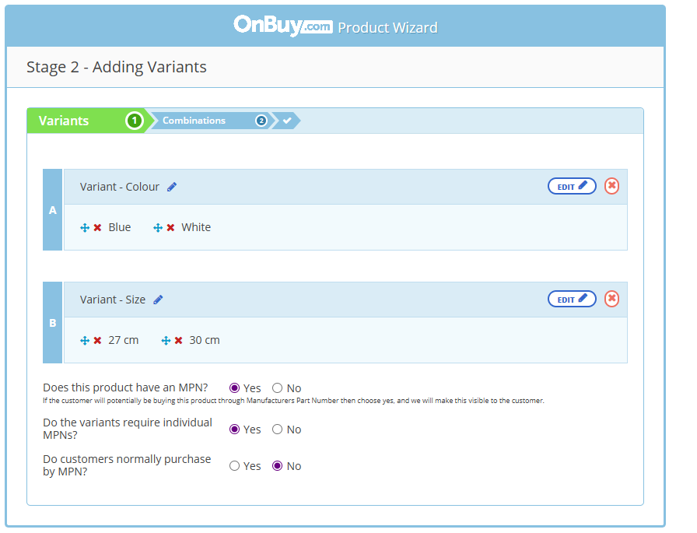
- So mixing up with our current system can be showed like this
(when clicked on this button only rest appears)
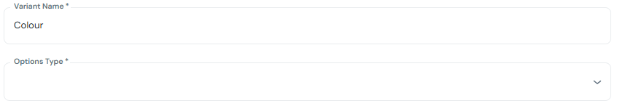
If Colour is entered then ask Colour options instead of options type and allow sellers to add up
If Size is entered then ask Size options instead of options type and allow sellers to add up
Change the box with dropdown and place something like sellers can add up,find the example below:

- Then Variant B and same thing again, after they add both variants just show them both Variant A & Variant B together (refer screenshot)
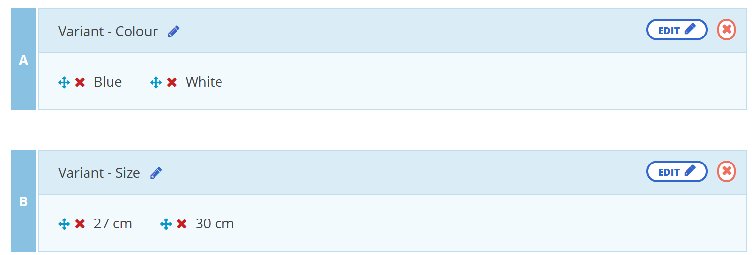
(Just for reference, I prefer completely blending up with our current system)
- The system should assume as if both colours are having both sizes
For ex: Blue shud have 27cm and 30 cm
And there's no assurance that those sizes should be available for that specific colour, so sellers should be able to confirm
- Then,
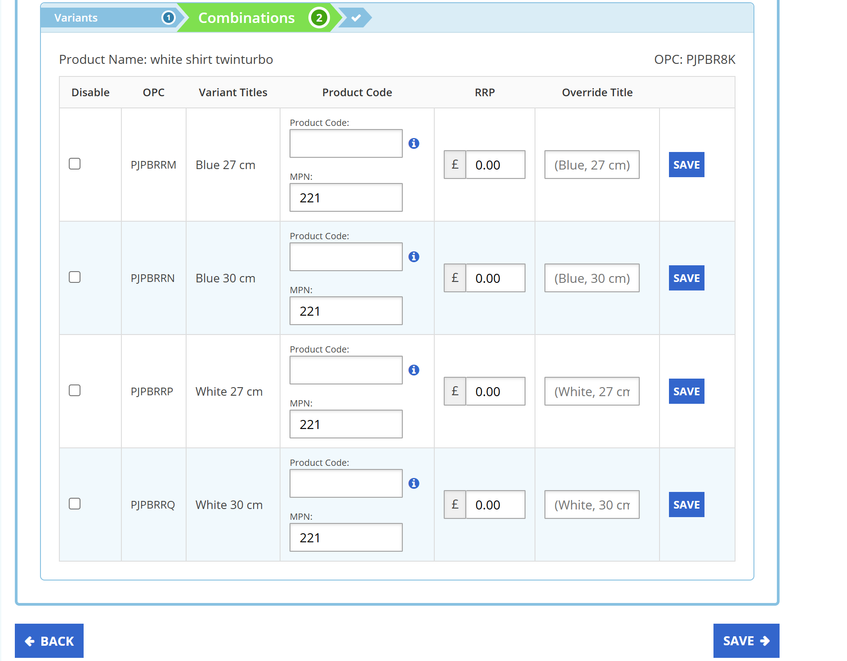
As I clicked ‘No’ for the question ‘Do variants require individual MPN’, the MPN showed already filled up same code for all the variants.

- Instead of OPC write Sku
Auto generated skus in the rows or a small box inside the row to generate sku
- Third row Is needed
- Inside the first box in fourth row, first box writing should be EAN, UPC & second box as it is in the screenshot (MPN)
- RRP row not needed
- Override title needed without save and it shud be unclickable for sellers
- Without entering EAN & UPC, sellers can go to next step but if they had clicked yes for the question ‘Do the variants require individual MPNs’ then they cant jump to next stage without entering MPN
- Then Media section
Ask Do variants have different images? Yes/No
If clicked No then
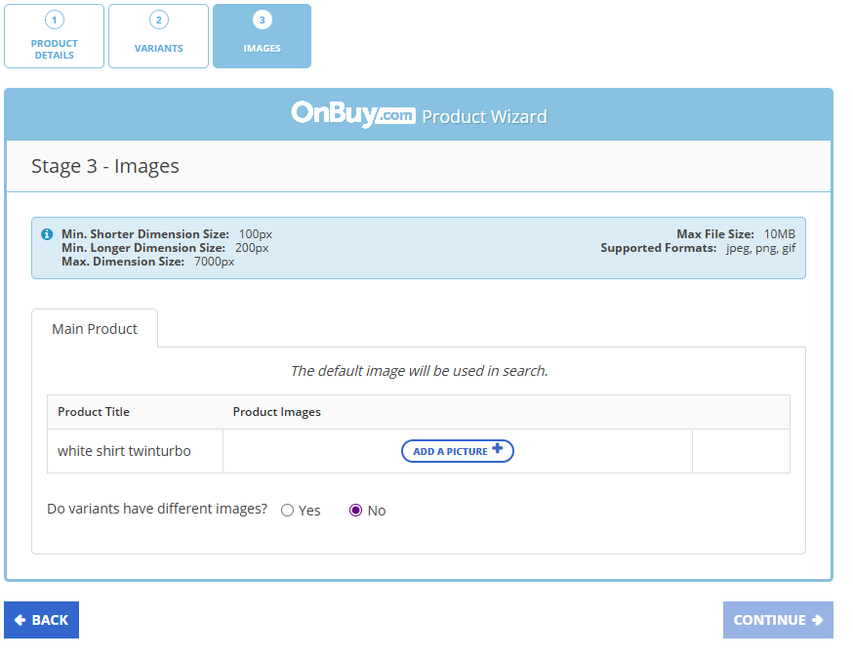
(Add standards for images)
If clicked Yes then
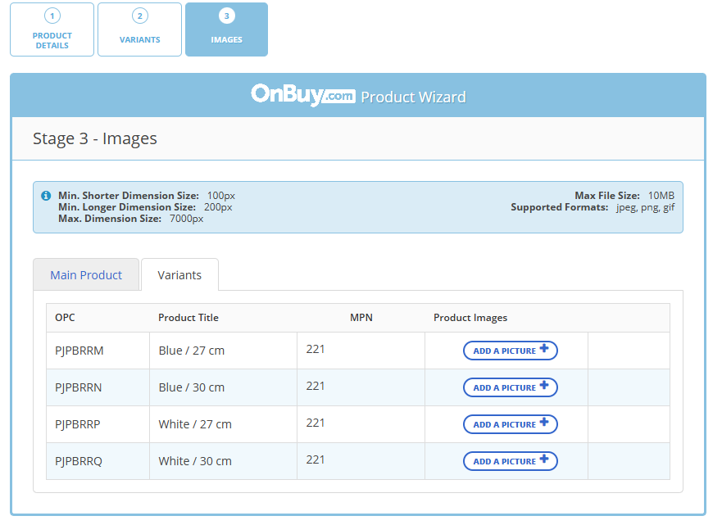
- Then in Detailed Product Info,
Ask ‘Do variants have different descriptions?’
If clicked No,then common description box & highlights adding box (refer screenshot below)

If clicked Yes, then description & highlights adding boxes specifically for each variant (refer the video below)
Description (two variants).mp4
- In Price & Tax,
- Don't ask for minimum quantity
- Discount should be specifically asked for each variants
- Then ask discount start date & end date for each variants
https://drive.google.com/file/d/1qA7MuxmHbQ5937WDpUY5VF1Zyn72YtmR/vie
w?usp=drive_link
- Include tax toggle should be placed accordingly for all variants
- Ask price in this way for particular variants
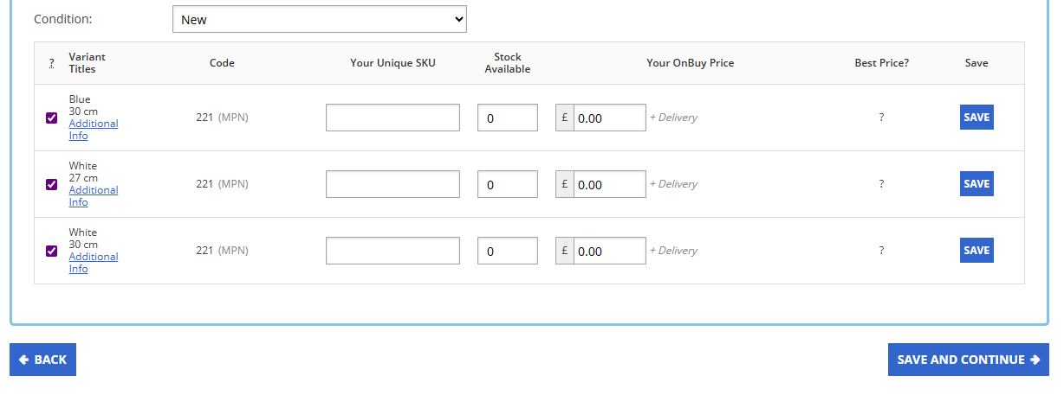
- Auto generated sku shud show in the third row
- Previously entered stock should show there
- Then box to enter price
- When clicked on additional info, Onbuy gives option to add sale price and all
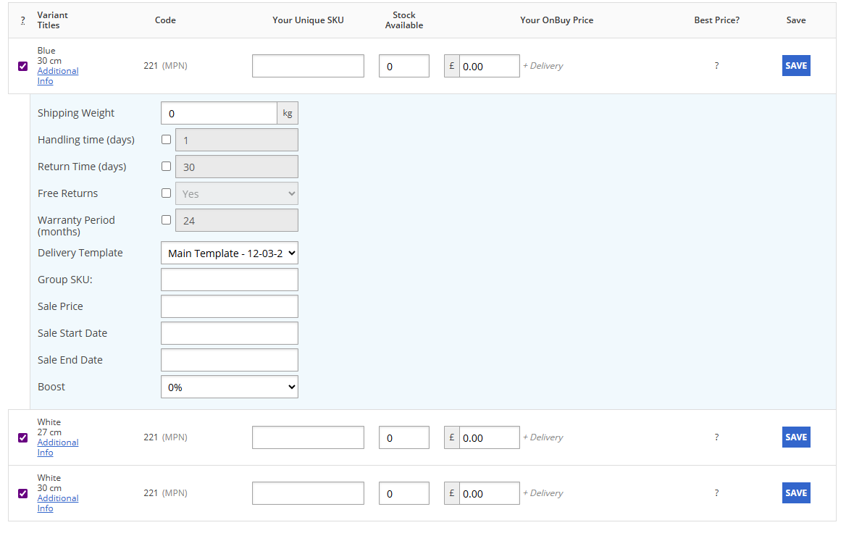
- Then Shipping
- Below questions should be asked for each variants
- Length Width Height Weight should be hidden in Shipping details
Reason: These are not required at listing stage because shipping charges will be calculated based on actual courier scans (Asyad). Collecting them from sellers is inaccurate, redundant, and adds friction to the listing flow
- Shipping charge should be shown 2omr, the box should be unclickable
- Shipping Days should also be unclickable showing 5-7 days.
- In return time show them the standard return time for Kaartx is 7 days, sellers can set their own return time as its not harming us in anyways. NOTE: They should not be able to set a time period below 7 days
If the item is returnable or refundable, it should be displayed in the product page
(will update in figma)
- After ask whether the item is returnable or not with a toggle
- If the Returnable toggle is on, then only ask for refundable toggle (needed)
- Also for Cancellation time, sellers can choose their own cancellation time
Standard cancellation time:5 hours, should not be below this time
- Hide warranty toggle, warranty duration & warranty description for now
- Then Review
